

Whareama School

www.whareama.school.nz

Newsletter No. 9

9th April, 2018

Term 1, Week 11

***END OF TERM ONE***

I cannot believe that we have already come to the end of Term 1. It has been a very busy term with so many things happening. Our roll continues to grow and we now have 44 students at our school with another 7 on our enrolments for the rest of the year. A huge welcome to Poppy Newell, Keoni Tiley, Star Jennings, Pippa and Bella Tua- Davidson to our Whareama whanau. We have many decisions to make as a school and that includes class sizes, bus runs, purchasing of resources and building work. Your Board of Trustees has so many things to consider at our next meeting on Wednesday, and we ask that you have your input in our upcoming community meeting on Thursday the 3rd of May, in the first week back at school. That evening will start at 5.00pm and we are aiming to complete the meeting within 1 hour. We all hope you have a chance to have a few days with your kids to help them recharge their batteries for the new term, which starts on Monday the 30th of April. I would like to say a quick thanks to the staff and board for all their hard work this term as our school grows and the challenges that this brings. Their perseverance and continual hard work ensures all of our students get the best deal possible here at Whareama School.

***WORKING BEE***

Due to there being many key people unavailable on the last Sunday of the holidays we have had to shift the working bee to Sunday the 20th of May. Please change this in your diaries and it has been updated on the school calendar as well.

***ANZAC DAY SERVICE***

The ANZAC service at Tinui will be on Wednesday the 25th of April, at 10.30am. This year Kaitlyn and Bryana will be doing the readings on the cenotaph for our school. We know they will do a great job.

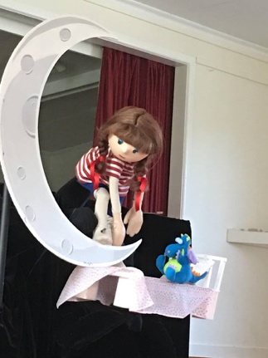

***PUPPET SHOW***

A huge thanks to playgroup for inviting our Junior Room to the Little Dog Barking Company’s performance of Twinkle on Wednesday last week. The Junior Room had a blast and everyone thoroughly enjoyed the trip to the hall for this special performance.

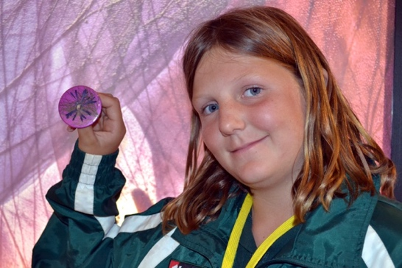***KIDZ CONFERENCE***

It sounded like the Kidz Conference was a huge success again and we would highly recommend all Year 6 – 8 students to look at this as an event they take part in next year. There were some memorable stories coming back to school about the event and it sounds like it was money well spent on all of the students.

***TAKE A KID FISHING DAY***

Sadly this day had to be postponed until Thursday the 10th of May next term.

***CLAYBIRD SHOOT***

Please support this year’s Claybird Shoot at Matariki, which is on the first Sunday of the school holidays, Sunday the 15th of April. If you need more information please call George at Matariki. Check out the flyer at the bottom of this newsletter.

***LITERMANIA***

Zarlia, Charlee, Rane and Poppy went along to the Litermania competition at MIS on Thursday in Week 9. They all enjoyed the challenge and came a commendable 5th place. This was the first year of this event and we look forward to being part of it in future years.

***LEARNING AMBASSADORS***

Kaitlyn and Mathew had a good day with all the Learning Ambassadors this morning and they had some excellent input into the future planning for 2018. They will no doubt be able to lead from the front in this group and plan with all the other.

***LUNCH ORDERS – WEEK 1 Next Term***

These will start again at the end of Week 1 next term. Orders in by Thursday in Week 1 please.

**Upcoming Events:**

**TERM 1:**

Weds 11th April BOT Meeting

Fri 13th April Term 1 Ends

Mon 30th April Term 2 Starts

Thurs 3rd May SCHOOL COMMUNITY MEETING – 5pm

Thurs 10th May Take a Kid Fishing Day

SUNDAY 20TH MAY SCHOOL WORKING BEE – 10am

Ω

Regards

Darren, Heather, Sandy and Diana

